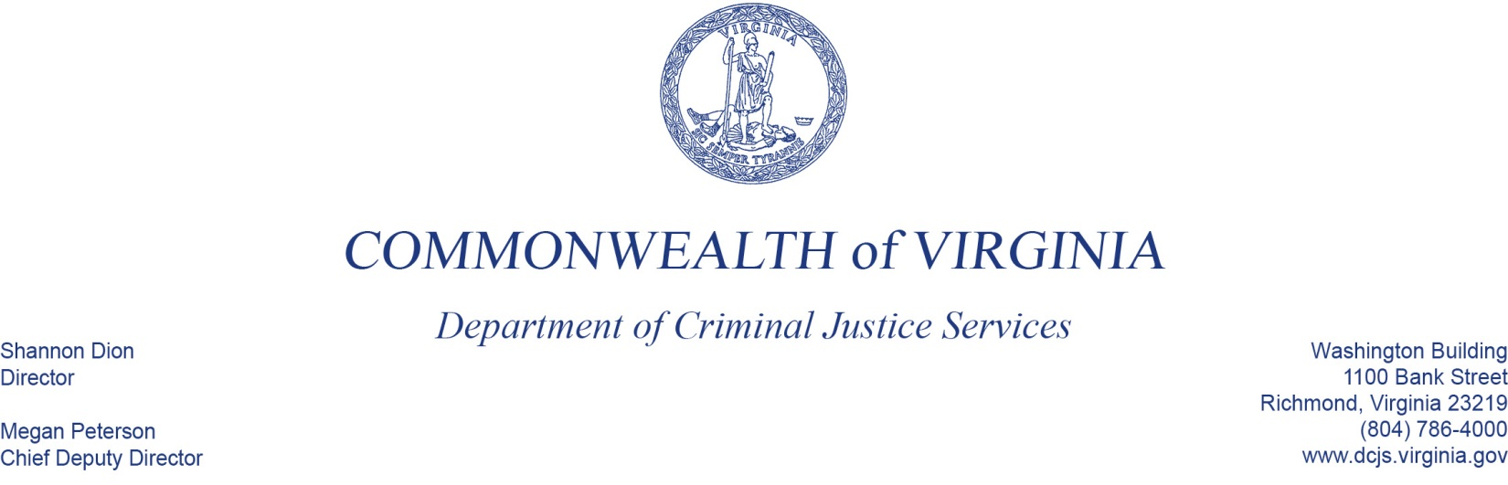
DCJS Compliance Monitoring:
Enhanced Programmatic Desk Review
Sexual Assault Response & Awareness (SARA): Grants #20-A2333VP18; 20-J2351DV20; 20-J2330SP19
April 2, 2020
9:00 A.M.
Conference Line: Line: 866-845-1266
Conference Code (participants): 92635532

Purpose:
The Department of Criminal Justice Services (DCJS) Grant Monitoring Plan ensures that sub-grantees are in compliance with all grant conditions. The department develops a risk-based monitoring plan, conducts fiscal and programmatic monitoring on all sub-grantees, and enhanced monitoring of sub-grantees determined to be medium and high risk.

Definitions:
Enhanced Financial Desk Review – In-depth monitoring performed remotely from the grantor site. Financial monitors assess the financial integrity and accountability of their grants and grantees using virtual and telephone communication methods for interacting with grantees and reviewing grant general ledgers and supporting documents.

DCJS Staff:
Amia Barrows, Victims Services Grant Monitoring Supervisor, amia.barrows@dcjs.virginia.gov
Chrissy Smith, Victims Services Specialist Chrissy.smith@dcjs.virginia.gov
Will Abbott, Grants Management Fiscal Monitor, will.abbott@dcjs.virginia.gov

AGENDA

09:00 AM Entrance Conference (facilitated by Amia Barrows)
    - DCJS and Program Staff (Amia, Chrissy, and Will)
    - Overview of Items for Review (Amia)
    - Enhanced Financial Desk Review Overview (Will)

09:30 AM Overview of Grant-Funded Programs Progress (Presented by the Project Director)

10:30 AM Interview with Grant Funded Staff (facilitated by DCJS Staff)

- Laura Guilliams, Director of Crisis Services, 540-420-7914 (10:30 AM-11:15AM)
- Kaisha Williams, Director of Clinical Services, 540-400-1192 (11:15AM-12:00AM)

BREAK

- Sherry Lawrence, SARA Finance Officer 540-793-2868 (1:00PM-1:30PM) (also FO, BOD Treasurer/Secretary)
- Tonia Drewery, SARA Project Administrator 540-312-5413 (1:30PM-2:00PM) (also BOD President)
- Dina Hackley-Hunt, Director of Education and Outreach, 540-798-3212 (2:00 PM-2:4PM)

BREAK

3:30 – 4:00 PM Discussion of Next Steps (facilitated by Amia Barrows and Chrissy Smith)
- Conclusion of staff interviews
- Preliminary findings
- Questions and comments with ED and Board President
- Electronic submission

